

`

TOM Integration
Specification
Space, Range and Display SEL Emergency Facings
RPP to IDS

S101

Project BEN Code: | W60416
Author: | Andy Barker
Date: | 12 Sep. 07
Version: | 0.2
Status: | Draft
Modified By: | Andy Barker
Reviewed By:

Change Record
Author | Date | Version | Change Reference, description
Andy Barker | 12 Sep. 07 | 0.1 | Draft
Andy Barker | 14 Sep. 07 | 0.2 | Removed primary key from trans table.

Reviewers
Name | Position
Shajitha Mohammed | Designer
Evelyn Ponraj | Developer
John Cowper | Solution Architect
Prasanth Dukaram | Development Lead

Sign-Off

By signing this form, I understand and agree with the contents of this document.
Business Owner/Customer | Andy Barker
Position | Engagement Architect
Signature | <Physical signature or via email approval>
Date | dd/mm/yyyy (<version signed off>)

Distribution List
Name | Date of Issue | Version
Jon Braggs
John Cowper
Jim Jeffery
Shajitha Mohammed
Evelyn Ponraj
Prasanth Dukaram

Document Source
DocShare: UK IT/TOM Integration/Shared Documents

Related Documents
- Mapping Spreadsheet:
S039TR_C023TR_S101_S092 - SRD SEL (SR and RPP to StoreLine) Mappings 0.1.xls (tab “Mapping S101”)
- RPP Interface design:
GPM External Interfaces Design v0.3.doc (MSWord document – contact John Cowper)
- TOM RIDS Model version 7.2 (Erwin document – contact John Jolley)
- S039TR Integration Design:
S039TR SRD SEL (SR to IDS) Interface Spec 0.1.doc (MSWord document – in docshare)

Table of Contents
1 Introduction 4
1.1 Purpose of Document 4
1.2 Background 4
1.3 Scope 4
2 Description and Requirements for the Interface 5
2.1 Scope 5
2.2 Detailed description of the end-to-end interface 5
2.3 Logical Schematic (physical location of components may differ) 6
2.4 Components in the End-to-End Interface 6
2.4.1 Data read 6
2.4.2 Data transformation 6
2.4.3 Data load 6
3 Source / Target Definitions 8
3.1 Source Message Schema 8
3.2 Source Technical Details 8
3.3 Target Message Schema 9
3.4 Target Technical Details 9
4 Non-Functional Requirements 11
5 Assumptions and Outstanding Issues 12
5.1 Assumptions 12
5.2 Outstanding Issues 12

Introduction

Purpose of Document
The purpose of this document is to describe the interfacing requirements w.r.t Emergency Facings data from Product Positioning (RPP) to Integration Data Store (IDS). The document is of a sufficiently technical nature to allow a developer to build an actual interface. Additionally the document contains detail that might sit logically within a Technical System Design (TSD) document, but is contained here for expediency. There is therefore no associated TSD for this interface.

Interface S101 is not currently required in the US, as product mapping of exceptions is not performed at this time.

Background
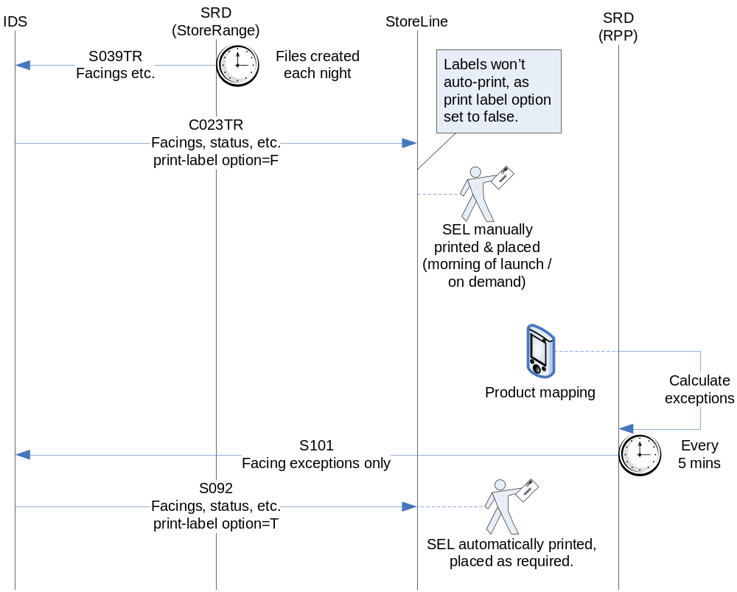

SRD manages a group of attributes which are required either to appear on Storeline shelf-edge-labels (SELs) or to be used by Storeline in its processes to produce the SELs.
These attributes are configured in JDA by the planogramming process, and from there passed to StoreRange and RPP. At certain points in the item in store lifecycle, StoreRange issues these attributes via files SR39 and SR92, which are required in an overnight feed to the IDS (S039TR) and onwards to Storeline (C023TR). The Storeline user will select when and how to group-print labels, which will contain both the SRD attributes together with RMS-sourced attributes (e.g. Price). Labels will not be automatically printed as part of this process.
Where product mapping indicates an in-store deviation from facings created on the planogram, the RPP application (“product-mapping” application) will emit a record on the emergency facings feed. Interface S101 (i.e. this interface) transfers this in near real-time to IDS, and S092 from there to Storeline. This feed only corrects the “facings” attribute (sending all others as null), and will result in a label being immediately printed in-store for the person doing the product mapping to replace on the shelf.

Scope
The Interface Specification covers:

- audit requirements across the interface
- security requirements across the interface
- timing/frequency requirements or constraints
- support requirements
- archiving
- the data format to be used for the interface at each stage (e.g. xml messages)
- the normal processing required at each stage
- recovery from failure required at each stage
- volumes.

Note that it is Tesco strategy to avoid placing any business logic in integration layer processing.

Description and Requirements for the Interface

Scope
A user in store will perform the product mapping process, where the actual facings of an item on a shelf are compared with those provided by the central planogramming activity. Where a discrepancy is found, RPP will emit a record via its holding table to the integration layer. In near-real-time (scheduled from CA Autosys), this interface (S101) is required to read the record from that table, transform it as required, load it into the IDS, and mark the source record as processed.

Detailed description of the end-to-end interface
RPP may contain records keyed on item and store in the outbound holding table tbl_ProductFacings_Outbound. When scheduled, S101 reads records that have been inserted by RPP since the last execution by checking for NULL in IL_Time_Stamp.

It is not safe to assume that a particular sku-store combination will be unique in source, so this interface deduplicates to process only the last such duplicate into the IDS.

The data is transformed according to the mapping spreadsheet (see “Related Documents” section), before being either updated or inserted into the IDS SKUItemInStore table depending on existence of the sku-store combination in that table.
On an insert, unfulfilled fields should be inserted as NULL. On an update, any fields not contained in source should be left as-is within the target table.

Once the functional data is successfully upserted into SKUItemInStore, a transaction control table SRDSEL_Trans has a record inserted to indicate which sku-store combination has changed, and that this was part of the emergency facings process. Details of this insert are also provided in the mapping spreadsheet.
Following successful completion, the integration component updates the source records with a consistent timestamp for all records processed in this cycle – thus preventing re-processing on next execution.

Logical Schematic (physical location of components may differ)
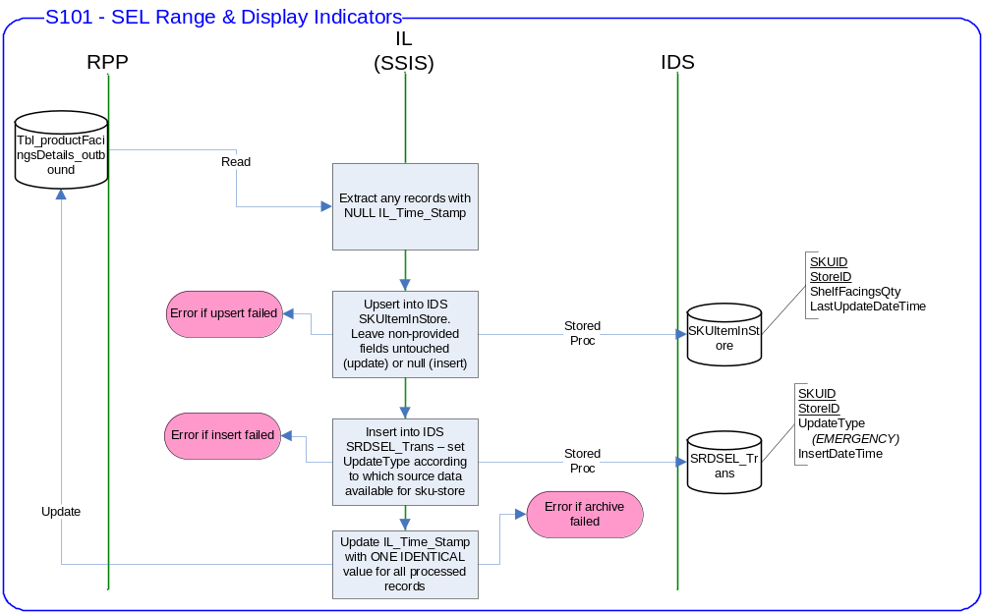

Components in the End-to-End Interface
SSIS
Package Name: TOM.S101.RPPtoIDS.SELEmergencyFacings.dtsx
SSIS Procedure
Name | S101_UpdateSELEmergencyFacings_usp
IDS Stored Procedure
Name | SRD_UpsertSELIndicators
IDS Transaction Table
Name | SRDSEL_Trans  (see target definition for details)
Note to developers: These names are a guide only. Please add as required, and / or rename in consistent fashion with other previously delivered SRD integration components, and update this section accordingly. Please also add specific details of the stored procedure arguments and return codes.

Data read
The integration component S101 is executed on a batch basis (expected to be once per day), and consists of a SQL Server Integration Services (SSIS) package that reads data from the tbl_ProductFacingsDetails_Outbound holding table located in the RPP database server.

Data transformation
The data is transformed in standard SSIS components as required. Mapping is provided in the document listed in the “Related Documents” section.

Data load

Upserts into SKUItemInStore, and inserts into SRDSEL_Trans, is via a single stored procedure delivered as part of this package, and called from the SSIS package.
A non-standard table is required in IDS for managing the transactions (SRDSEL_Trans). Details of the table definition can be found in the “Target Message Schema” section of this document.
The integration layer SSIS component will pass a string identifying this as an emergency facings update to the IDS stored procedure.

For details of the IDS stored procedure, provisionally called “SRD_UpsertSELIndicators”, please refer to the design for S039TR listed in the “Related Documents” section.

Source / Target Definitions

Source Message Schema
The data for this interface resides in a holding table in the RPP database.

SEL Emergency Facings: tbl_ProductFacingsDetails_Outbound

Field | Type | Notes
SKUID | varchar(50)
StoreID | int
FacingWide | int
InsertBy | varchar(30) | Ignore
InsertDate | datetime | Ignore
IL_Time_Stamp | datetime | Only select where NULL. Update at end.
AmendDate | datetime | Ignore
AmendBy | varchar(30) | Ignore
IsDeleted | bit | Ignore
ErrorNumber | int | Ignore
ErrorMessage | text | Ignore

Source Technical Details
Feature | Specification | Additional Information
Source System Name | RPP
Source Platform / OS | Windows 2003 Server
Source Physical Location | tbl_ProductFacingsDetails_Outbound | Should be configurable
Source Underlying Data Storage Technology | SQL Server 2005
Transfer Function | HTTP (Put/Post) □  HTTPS (Put/Post) □  Message Queue □  FTP □  File Drop(Windows) □  (XCOM) □  SSIS ☑
Data Format. | XML □  Delimited □  Positional □  RDBMS ☑
Decryption/Encryption | No
Decompression/Compression | No
Transmission Mode | Synchronous ☑  Asynchronous □  Bulk Data □
Real-time/Scheduled Batch | Scheduled Batch
Archiving | Records logically deleted by updating IL_Time_Stamp on completion.
Logging | Log via the Operational Framework.
Error Handling | Processing should prevent sending of duplicate messages, unless this occurs during recovery from failure.

Target Message Schema
Table SKUItemInStore (RIDS v7.2):
Field | Format | Comments
SKUID | varchar(25) NOT NULL | Primary key
StoreID | integer NOT NULL | Primary key
WICInd | char(1) NULL | <not an SRD attribute>
PricingUOM | varchar(4) NULL | <not an SRD attribute>
MeasureOfEach | numeric(12,4) NULL | <not an SRD attribute>
MeasureOfPrice | numeric(12,4) NULL | <not an SRD attribute>
ProductStoreRangeStatus | tinyint NULL | “Range” attribute
ProductStoreStatus | tinyint NULL | “Range” attribute
MultiLocationInd | char(1) NULL | “Display” attribute
ShelfFacingsQty | smallint NULL | “Display” attribute
PlanogramID | varchar(25) NULL | “Range” attribute
SELQty | tinyint NULL | “Display” attribute
LocalSKUDescription | varchar(250) NULL | <not an SRD attribute>
LocalShortSKUDescription | varchar(120) NULL | <not an SRD attribute>
LastUpdateDateTime | datetime NULL

Table SRDSEL_Trans (to be created as part of this deliverable):
Field | Format | Comments
SKUID | varchar(25) NOT NULL
StoreID | integer NOT NULL
UpdateType | varchar(10) NOT NULL | To contain one of the following 4 values: “FULL” / “RANGE” / “FACINGS” / “EMERGENCY”  S039TR will insert one of the first 3, S101 will always insert “EMERGENCY”.  Extract process C023TR (S092) will use this to identify which rows are relevant, and which fields to extract from SKUItemInStore for the type of run.
InsertDateTime | datetime NOT NULL | Sysdatetime of insertion
ExtractDateTime | datetime NULL | NULL until successful extract.
BatchNumber | integer NULL | NULL until successful extract

Target Technical Details
For messages destined for IDS (from SR in Integration layer), the following applies:

Feature | Specification | Additional Information
Target System Name | IDS
Target Platform / OS | Windows 2003 Server
Target Physical Location | IL
Target Underlying Data Storage Technology | RDBMS
Transfer Function | HTTP (Put/Post □  HTTPS (Put/Post) □  Message Queue □  FTP □  File Drop (Windows) □  (XCOM) □  RTI File Adapter □  SSIS ☑ | Stored Proc call.
Data Format | XML □  Delimited □  Positional □  RDBMS ☑
Decryption/Encryption | No
Decompression/Compression | No
Transmission Mode | Synchronous ☑  Asynchronous □  Bulk Data □
Real-time/Scheduled Batch | Called from SSIS directly
Archiving | N/A
Logging | Log via the Operational Framework.
Error Handling | Return from Stored Proc must be logged

Non-Functional Requirements
Audit Requirements | The interface will use the components provided by the Operational Framework to satisfy audit requirements.
Security Requirements | The interface executes within a secure private domain. There is no additional security considerations required.
Timing/Cut-off Constraints | S101 must be scheduled as a required precursor to C023TR (logically S092), which will extract the data from IDS to transmit to StoreLine.  This process, and C023TR, must wait for the regular feed S039TR/C023TR to complete if they are already running, but it should run as normal as soon as possible once the regular process completes.
Performance Requirements | Not known at this stage.
Reliability and Availability Requirements | Not known at this stage.
Scalability Requirements | No Scalability requirement. The requirement is to deliver a single extract. It is anticipated that the volume of data transferred will continue to remain within the capability provided by this implementation.
Operational Support Requirements | The successful delivery, failure in the creation of the extract, and failure in message transport, must be recorded by the Integration Management Operational Framework (IMOF). In the event of failure, an alert should be raised.
Likelihood of Change Requirements | Not known at this stage.
Cultural/Global Consideration Requirements | Although multi-byte character set support is not required for US or Turkey, the interface will support multi-byte character sets through integration.
Legal Requirements | N/A
Compliance To Standards Requirements | No compliance exceptions.

IL to update source records with a timestamp following successful completion. All source / targets must be run-time configurable.

The interface will make use of the audit and traceability components that are being developed as part of the Operational Framework stream. These components will be pluggable, and will be useable from BizTalk, RTI and SSIS. At the time of writing (2007-09-13) the components are in design. Developers should put a ‘placeholder’ in their code / configurations as appropriate, and meantime handle errors and exceptions as per the already delivered SRD integration components.

Assumptions and Outstanding Issues

Assumptions
ID | Assumption

Outstanding Issues
ID | Issue | To be addressed by

